**Manav Rachna International Institute of Research and Studies Bachelor's in computer applications**

**Data Structures using C**



**Name:** Yashika Saini

**Roll No:** 24/SCA/BCA/055

**Department:** School of Computer Applications

**Course:** Bachelor of Computer Applications

**Semester:** 2nd

**Subject:** Data Structures using C

**Program 1**

**AIM:** Write a program in C to implement Insertion in 1-D Arrays.

**CODE:**

#include <stdio.h>

int main() {

int arr[5];

int n, count=0, loc, upd;

printf("Enter the elements of array\n");

for(int i=0; i<5; i++){

scanf("%d",&arr[i]);

}

return 0;

}

**OUTPUT:**

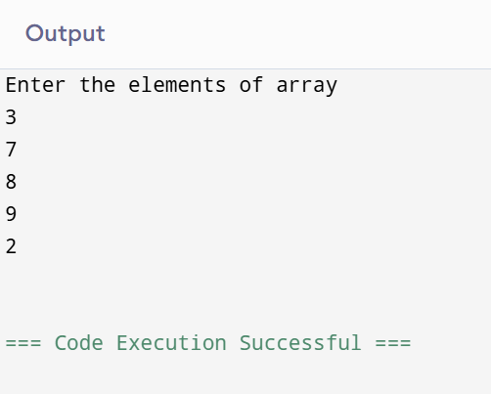

**PROGRAM 2**

**AIM:** Write a program in C to implement deletion in 1-D arrays.

**CODE:**

#include <stdio.h>

int main(){

int count = 0;

int x;

int arr1[] = {1,2,3,4,5};

printf("Enter the element you want to delete: \n");

scanf("%d", &x);

for(int i = 0; i<5; i++){

if(arr1[i] == x){

for(int j = i; j<5; j++){

arr1[j] = arr1[j + 1];

}

count = count + 1;

}

}

if(count == 0){

printf("Element is not found");

} else{

for(int i = 0; i<4; i++){

printf("%d\t", arr1[i]);

}

return 0;

}

}

**OUTPUT:**

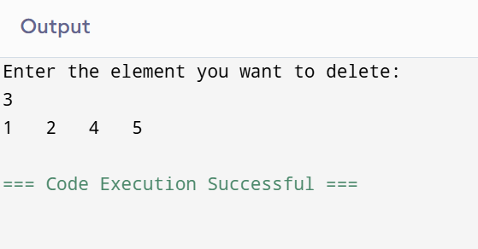

**PROGRAM 3**

**AIM:** Write a program in C to implement searching in 1-D arrays.

**CODE:**

#include <stdio.h>

int main() {

int arr[5];

int n,count=0 , loc, upd;

printf(" enter the elements of array \n");

for(int i=0; i<5; i++){

scanf("%d",&arr[i]);

}

printf("enter the element you want to find\n");

scanf("%d",&n);

for(int i=0; i<5; i++){

if(arr[i] == n){

printf("%d found at location %d\n",n,i+1);

count +=1;

}

}

if(count == 0){

printf("%d not founded\n", n);

}

return 0;

}

**OUTPUT:**

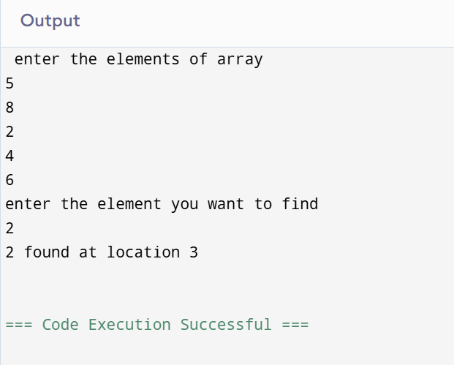

**PROGRAM 4**

**AIM:** Write a program in C to implement sorting in 1-D arrays.

**CODE:**

#include <stdio.h>

int main() {

int arr[5];

printf(" Enter five elements \n");

for(int i=0; i<5; i++){

scanf("%d",&arr[i]);

}

int temp;

for(int i=0; i<5; i++){

for(int j=0; j<4-i; j++){

if(arr[j] > arr[j+1]){

temp = arr[j];

arr[j] = arr[j+1];

arr[j+1] = temp;

}

}

}

printf("Ascending order\n");

for(int i=0; i<5; i++){

printf("%d\t",arr[i]);

}

for(int i=0; i<5; i++){

for(int j=0; j<4-i; j++){

if(arr[j] < arr[j+1]){

temp = arr[j];

arr[j] = arr[j+1];

arr[j+1] = temp;

}

}

}

printf("\nDescending order\n");

for(int i=0; i<5; i++){

printf("%d\t",arr[i]);

}

return 0;

}

**OUTPUT:**

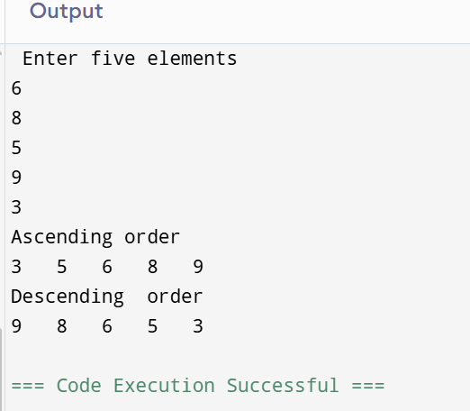

**PROGRAM 5**

**AIM:** Write a program in C to implement push operation in stacks.

**CODE:**

#include <stdio.h>

#include <stdlib.h>

#define MAX 5

struct Stack {

int arr[MAX];

int top;

};

void initStack(struct Stack* stack) {

stack->top = -1;

}

int isFull(struct Stack* stack) {

return stack->top == MAX - 1;

}

void push(struct Stack* stack, int value) {

if (isFull(stack)) {

printf("Stack Overflow! Cannot push %d\n", value);

} else {

stack->arr[++(stack->top)] = value;

printf("%d pushed to stack\n", value);

}

}

void printStack(struct Stack* stack) {

if (stack->top == -1) {

printf("Stack is empty\n");

} else {

printf("Stack elements: ");

for (int i = 0; i <= stack->top; i++) {

printf("%d ", stack->arr[i]);

}printf("\n");

}

}

int main() {

struct Stack stack;

initStack(&stack);

push(&stack, 10);

push(&stack, 20);

push(&stack, 30);

push(&stack, 40);

push(&stack, 50);

push(&stack, 60);

printStack(&stack);

return 0;

}

**OUTPUT:**

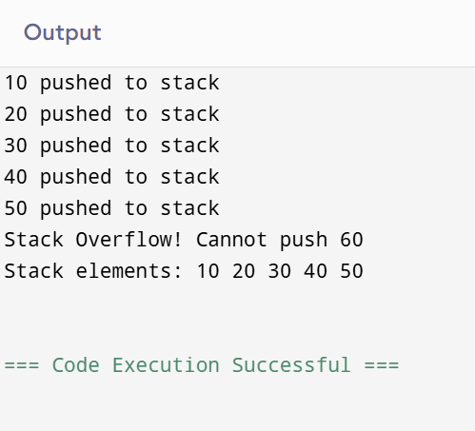

**PROGRAM 6**

**AIM:** Write a program in c to implement pop operation in stacks.

**CODE:**

#include <stdio.h>

#include <stdlib.h>

#define MAX_SIZE 100

struct Stack {

int arr[MAX_SIZE];

int top;

};

void initialize(struct Stack *stack) {

stack->top = -1;

}

int isEmpty(struct Stack *stack) {

return stack->top == -1;

}

int pop(struct Stack *stack) {

if (isEmpty(stack)) {

printf("Stack Underflow! Cannot pop element from empty stack.\n");

return -1;

}

return stack->arr[stack->top--];

}

int main() {

struct Stack stack;

initialize(&stack);

stack.arr[++stack.top] = 10;

stack.arr[++stack.top] = 20;

stack.arr[++stack.top] = 30;

printf("Popped: %d\n", pop(&stack));

printf("Popped: %d\n", pop(&stack));

printf("Popped: %d\n", pop(&stack));

printf("Popped: %d\n", pop(&stack));

return 0;

}

**OUTPUT:**

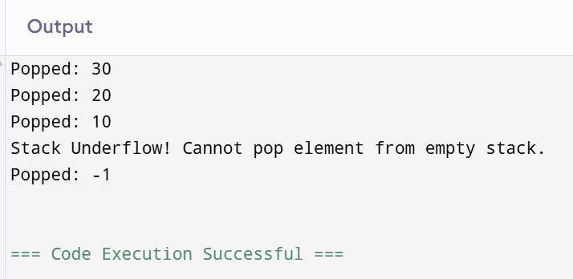

**PROGRAM 7**

**AIM:** Write a program in c to implement insertion in linked list (beg, mid, end)

1. **Insertion in beginning**

**CODE:**

#include <stdio.h>

#include <stdlib.h>

struct Node {

int data;

struct Node* next;

};

void insertAtBeginning(struct Node** head_ref, int new_data) {

struct Node* new_node = (struct Node*)malloc(sizeof(struct Node));

new_node->data = new_data;

new_node->next = (*head_ref);

(*head_ref) = new_node;

}

void printList(struct Node* node) {

while (node != NULL) {

printf("%d ", node->data);

node = node->next;

}

printf("\n");

}

int main() {

struct Node* head = NULL;

insertAtBeginning(&head, 70);

insertAtBeginning(&head, 60);

insertAtBeginning(&head, 50);

insertAtBeginning(&head, 40);

insertAtBeginning(&head, 30);

insertAtBeginning(&head, 20);

insertAtBeginning(&head, 10);

printf("Linked list after insertions: ");

printList(head);

return 0;

}

**OUTPUT:**

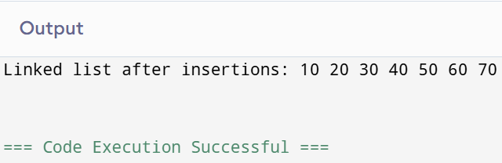

1. **Insertion at middle**

**CODE:**

#include <stdio.h>

#include <stdlib.h>

struct Node {

int data;

struct Node* next;

};

void insertAtMiddle(struct Node** head_ref, int new_data) {

struct Node* new_node = (struct Node*)malloc(sizeof(struct Node));

if (new_node == NULL) {

printf("Memory allocation failed\n");

return;

}

new_node->data = new_data;

new_node->next = NULL;

if (*head_ref == NULL) { // If the list is empty

*head_ref = new_node;

return;

}

struct Node* slow_ptr = *head_ref;

struct Node* fast_ptr = *head_ref;

struct Node* prev_slow = NULL;

while (fast_ptr != NULL && fast_ptr->next != NULL) {

fast_ptr = fast_ptr->next->next;

prev_slow = slow_ptr;

slow_ptr = slow_ptr->next;

}

new_node->next = slow_ptr;

if (prev_slow != NULL) {

prev_slow->next = new_node;

} else {

*head_ref = new_node;

}

}

void printList(struct Node* node) {

while (node != NULL) {

printf("%d ", node->data);

node = node->next;

}

printf("\n");

void freeList(struct Node* head) {

struct Node* tmp;

while (head != NULL) {

tmp = head;

head = head->next;

free(tmp);

}

int main() {

struct Node* head = NULL;

insertAtMiddle(&head, 1);

insertAtMiddle(&head, 2);

insertAtMiddle(&head, 4);

insertAtMiddle(&head, 5);

printf("Linked list before insertion: \n");

printList(head);

insertAtMiddle(&head, 3);

printf("Linked list after insertion: \n");

printList(head);

freeList(head); // Free allocated memory

return 0;

}

**OUTPUT:**

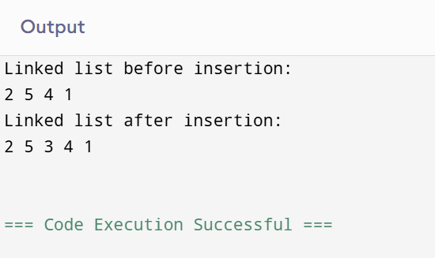

1. **Insertion at ending**

**CODE:**

#include <stdio.h>

#include <stdlib.h>

struct Node {

int data;

struct Node* next;

};

void insertAtEnd(struct Node** head_ref, int new_data) {

struct Node* new_node = (struct Node*)malloc(sizeof(struct Node));

struct Node *last = *head_ref;

new_node->data = new_data;

new_node->next = NULL;

if (*head_ref == NULL) {

*head_ref = new_node;

return;

}

while (last->next != NULL)

last = last->next;

last->next = new_node;

return;

}

void printList(struct Node* node) {

while (node != NULL) {

printf("%d ", node->data);

node = node->next;

}

printf("\n");

}

int main() {

struct Node* head = NULL;

insertAtEnd(&head, 1);

insertAtEnd(&head, 2);

insertAtEnd(&head, 3);

insertAtEnd(&head, 4);

printf("Created Linked list is: ");

printList(head);

return 0;

}

**OUTPUT:**

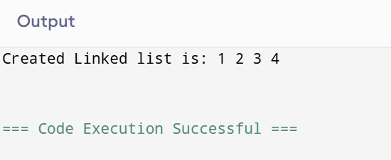

**PROGRAM 8**

**AIM:** Write a program in c to implement deletion in linked list (beg, mid, end)

1. **Deletion at beginning**

**CODE:**

#include <stdio.h>

#include <stdlib.h>

struct Node {

int data;

struct Node* next;

};

struct Node* deleteFromBeginning(struct Node* head) {

if (head == NULL) {

printf("List is empty, cannot delete.\n");

return NULL;

}

struct Node* temp = head;

head = head->next;

free(temp);

return head;

}

void printList(struct Node* head) {

struct Node* current = head;

while (current != NULL) {

printf("%d ", current->data);

current = current->next;

}

printf("\n");

}

struct Node* createNode(int data) {

struct Node* newNode = (struct Node*)malloc(sizeof(struct Node));

newNode->data = data;

newNode->next = NULL;

return newNode;

}

int main() {

struct Node* head = createNode(10);

head->next = createNode(20);

head->next->next = createNode(30);

printf("Linked list before deletion: ");

printList(head);

head = deleteFromBeginning(head);

printf("Linked list after deletion: ");

printList(head);

head = deleteFromBeginning(head);

printf("Linked list after second deletion: ");

printList(head);

head = deleteFromBeginning(head);

return 0;

}

**OUTPUT:**

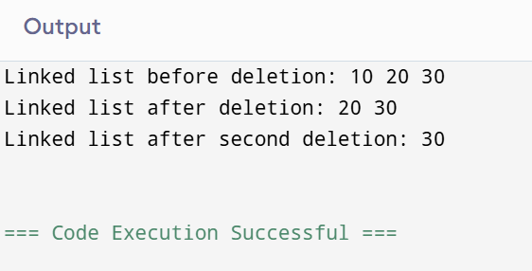

1. **Deletion at middle**

**CODE:**

#include <stdio.h>

#include <stdlib.h>

struct Node {

int data;

struct Node* next;

};

void insertEnd(struct Node** head_ref, int new_data) {

struct Node* new_node = (struct Node*)malloc(sizeof(struct Node));

struct Node* last = *head_ref;

new_node->data = new_data;

new_node->next = NULL;

if (*head_ref == NULL) {

*head_ref = new_node;

return;

}

while (last->next != NULL)

last = last->next;

last->next = new_node;

return;

}

void deleteMiddle(struct Node** head_ref) {

if (*head_ref == NULL || (*head_ref)->next == NULL) {

free(*head_ref);

*head_ref = NULL;

return;

}

struct Node* slow_ptr = *head_ref;

struct Node* fast_ptr = *head_ref;

struct Node* prev = NULL;

while (fast_ptr != NULL && fast_ptr->next != NULL) {

fast_ptr = fast_ptr->next->next;

prev = slow_ptr;

slow_ptr = slow_ptr->next;

}

prev->next = slow_ptr->next;

free(slow_ptr);

}

void printList(struct Node* node) {

while (node != NULL) {

printf("%d ", node->data);

node = node->next;

}

printf("\n");

}

int main() {

struct Node* head = NULL;

insertEnd(&head, 1);

insertEnd(&head, 2);

insertEnd(&head, 3);

insertEnd(&head, 4);

insertEnd(&head, 5);

printf("Linked list before deletion: ");

printList(head);

deleteMiddle(&head);

printf("Linked list after deletion of middle element: ");

printList(head);

return 0;

}

**OUTPUT:**

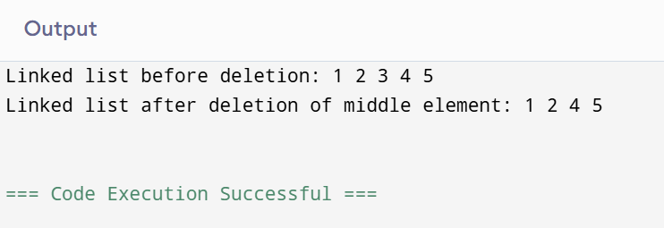

1. **Deletion at ending**

**CODE:**

#include <stdio.h>

#include <stdlib.h>

struct Node {

int data;

struct Node* next;

};

void deleteLastNode(struct Node** head_ref) {

if (*head_ref == NULL) {

return;

}

if ((*head_ref)->next == NULL) {

free(*head_ref);

*head_ref = NULL;

return;

}

struct Node* second_last = *head_ref;

while (second_last->next->next != NULL) {

second_last = second_last->next;

}

free(second_last->next);

second_last->next = NULL;

}

void push(struct Node** head_ref, int new_data) {

struct Node* new_node = (struct Node*)malloc(sizeof(struct Node));

new_node->data = new_data;

new_node->next = (*head_ref);

(*head_ref) = new_node;

}

void printList(struct Node* node) {

while (node != NULL) {

printf("%d ", node->data);

node = node->next;

}

printf("\n");

}

int main() {

struct Node* head = NULL;

push(&head, 7);

push(&head, 1);

push(&head, 4);

push(&head, 3);

printf("Created Linked list is: ");

printList(head);

deleteLastNode(&head);

printf("Linked list after deletion of last node: ");

printList(head);

deleteLastNode(&head);

printf("Linked list after deletion of last node: ");

printList(head);

return 0;

}

**OUTPUT:**

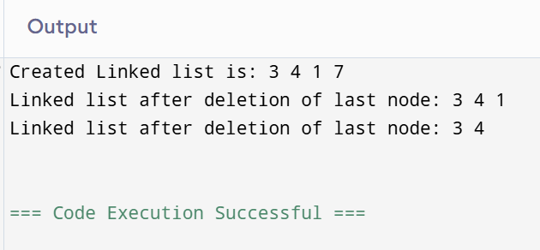

**PROGRAM 9**

**AIM:** Write a program in C to implement insertion in queue (enqueue)

**CODE:**

#include <stdio.h>

#include <stdlib.h>

#define MAX_SIZE 100

int queue[MAX_SIZE];

int front = -1;

int rear = -1;

int isFull() {

return (rear == MAX_SIZE - 1);

}

int isEmpty() {

return (front == -1);

}

void enqueue(int value) {

if (isFull()) {

printf("Queue Overflow! Cannot insert element.\n");

return;

}

if (isEmpty()) {

front = 0;

}

rear++;

queue[rear] = value;

printf("%d enqueued to queue\n", value);

}

int main() {

enqueue(10);

enqueue(20);

enqueue(30);

return 0;

**OUTPUT:**

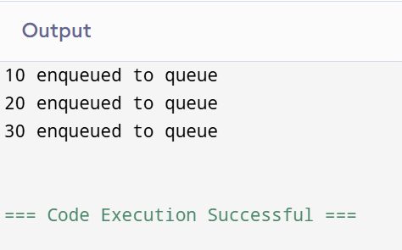

**PROGRAM 10**

**AIM:** Write a program in C to implement deletion in queue (dequeue)

**CODE:**

#include <stdio.h>

#include <stdlib.h>

#define MAX_SIZE 100

int queue[MAX_SIZE];

int front = -1;

int rear = -1;

int isEmpty() {

return front == -1;

}

void dequeue() {

if (isEmpty()) {

printf("Queue is empty. Cannot delete element.\n");

return;

}

printf("Deleted element: %d\n", queue[front]);

if (front == rear) { // If only one element in queue

front = rear = -1;

} else {

front++;

}

}

void display() {

if (isEmpty()) {

printf("Queue is empty.\n");

return;

}

printf("Queue elements: ");

for (int i = front; i <= rear; i++) {

printf("%d ", queue[i]);

}

printf("\n");

}

int main() {

queue[++rear] = 10;

if (front == -1) front = 0;

queue[++rear] = 20;

queue[++rear] = 30;

printf("Initial ");

display();

dequeue();

printf("After first deletion ");

display();

dequeue();

printf("After second deletion ");

display();

dequeue();

printf("After third deletion ");

display();

dequeue();

return 0;

}

**OUTPUT:**

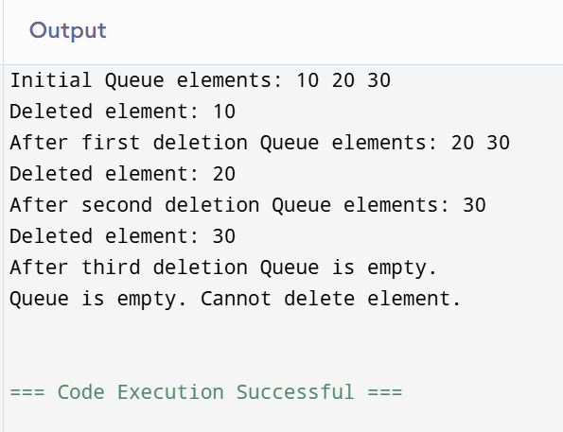

**PROGRAM 11**

**AIM:** Write a program in C to perform peek operation in queue

**CODE:**

#include <stdio.h>

#include <stdlib.h>

#define MAX_SIZE 100

typedef struct {

int arr[MAX_SIZE];

int front;

int rear;

} Queue;

void initializeQueue(Queue *q) {

q->front = -1;

q->rear = -1;

}

int isEmpty(Queue *q) {

return (q->front == -1 && q->rear == -1);

}

int isFull(Queue *q) {

return (q->rear == MAX_SIZE - 1);

}

void enqueue(Queue *q, int data) {

if (isFull(q)) {

printf("Queue is full. Cannot enqueue.\n");

return;

}

if (isEmpty(q)) {

q->front = 0;

}

q->rear++;

q->arr[q->rear] = data;

}

int peek(Queue *q) {

if (isEmpty(q)) {

printf("Queue is empty. Cannot peek.\n");

return -1;

}

return q->arr[q->front];

}

int main() {

Queue q;

initializeQueue(&q);

enqueue(&q, 10);

enqueue(&q, 20);

enqueue(&q, 30);

printf("Front element of the queue: %d\n", peek(&q));

return 0;

}

**OUPUT:**

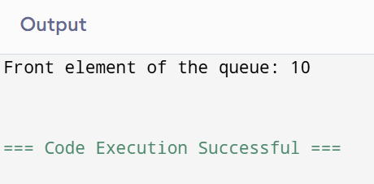

**PROGRAM 12**

**AIM:** Write a program in C to perform isEmpty operation in queue

**CODE:**

#include <stdio.h>

#include <stdlib.h>

#define MAX_SIZE 100

typedef struct {

int arr[MAX_SIZE];

int front, rear;

} Queue;

void initializeQueue(Queue *q) {

q->front = -1;

q->rear = -1;

}

int isEmpty(Queue *q) {

return (q->front == -1 && q->rear == -1);

}

int isFull(Queue *q) {

return (q->rear == MAX_SIZE - 1);

}

void enqueue(Queue *q, int value) {

if (isFull(q)) {

printf("Queue is full. Cannot enqueue.\n");

return;

}

if (isEmpty(q)) {

q->front = 0;

}

q->rear++;

q->arr[q->rear] = value;

}

int dequeue(Queue *q) {

if (isEmpty(q)) {

printf("Queue is empty. Cannot dequeue.\n");

return -1;

}

int value = q->arr[q->front];

if (q->front == q->rear) {

initializeQueue(q);

} else {

q->front++;

}

return value;

}

int main() {

Queue q;

initializeQueue(&q);

printf("Is queue empty? %s\n", isEmpty(&q) ? "Yes" : "No");

enqueue(&q, 10);

enqueue(&q, 20);

enqueue(&q, 30);

printf("Is queue empty? %s\n", isEmpty(&q) ? "Yes" : "No");

printf("Dequeued: %d\n", dequeue(&q));

printf("Dequeued: %d\n", dequeue(&q));

printf("Dequeued: %d\n", dequeue(&q));

printf("Is queue empty? %s\n", isEmpty(&q) ? "Yes" : "No");

return 0;

}

**OUTPUT:**

